14.60: a) Archimedes’ principle states 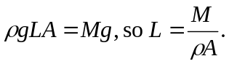
b) The buoyant force is 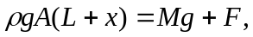 and using the result of part (a) and solving for x gives 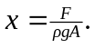
c) The “spring constant,” that is, the proportionality between the displacement x and the applied force F, is 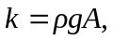 and the period of oscillation is
